Waves Open Air 2026
Awareness-Konzept (Stand: 02.04.2026)

AllAroundAwareness* +Initiative Barrierefrei Feiern
Contact Person: Rut Taame (she/her) rut@barrierefrei-feiern.de
General Contact: awareness@barrierefrei-feiern.de

Disclaimer
This concept does not cover the full complexity of the topic of "Awareness" but provides an overview of the jointly agreed-upon objectives and measures for orientation. Awareness work is understood as a conceptual component of a holistic system that ensures a sensitive and responsible approach to critical situations across all areas of the event. Beyond the operational cooperation of an external awareness team, "Awareness" is a mindset and strategy based on collective responsibility. Its effectiveness only unfolds if all participants support it. This results in a shared responsibility to actively engage with the principles of awareness and the underlying values individually, within teams, and in cooperation with external partners, service providers, and staff.

Definition Awareness
Awareness refers to a conscious, mindful interaction centered on mutual respect, sensitivity, and responsibility. It means critically questioning one's own behavior, perceiving and respecting the boundaries of others, and openly communicating one's own boundaries. At the same time, awareness includes proactive, psychosocial support work when critical incidents occur. An awareness concept is necessary to take action against discrimination as well as psychological, physical, or verbal violence and assault. It promotes shared responsibility carried by visitors, employees, and a trained awareness team. The goal is to make the festival a place where people feel as safe and respected as possible. In conjunction with a comprehensive security concept, awareness contributes to making everyone at the Waves Open Air Festival feel better protected and heard.

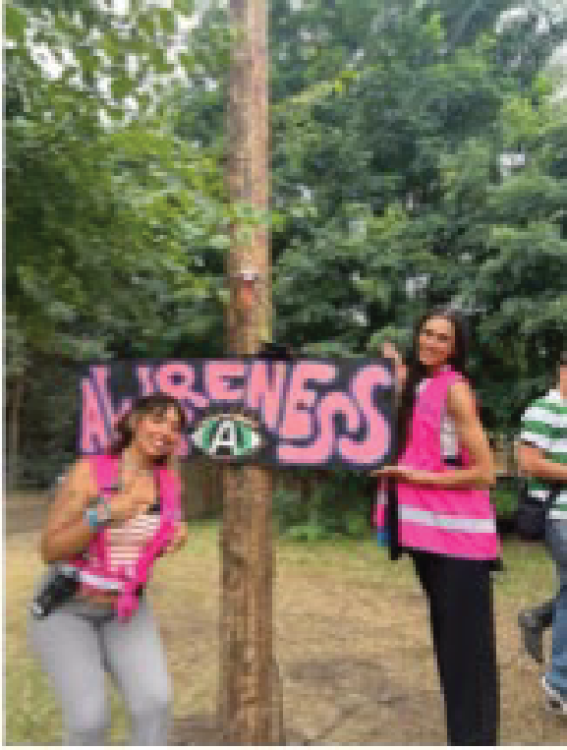
The Team
The awareness team consists of an intersectional group of "experts by experience" from AllAroundAwareness* and the Initiative Barrierefrei Feiern (IBF).

Under the motto "Intersectional. Solidary. Accessible.", the team combines professional expertise with diverse perspectives, particularly from marginalized communities.

Their work is based on intersectional anti-discrimination, peer support, and the goal of creating accessible and safe spaces for all participants.


Visibility & Accessibility

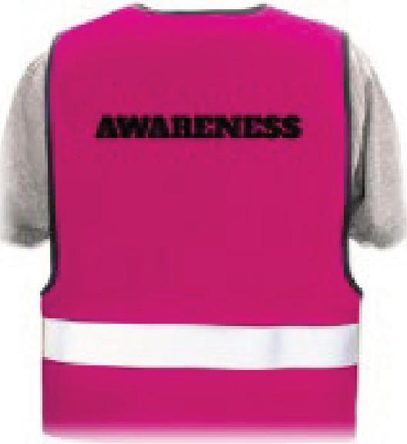
    - Presence: The Awareness Team is on duty on all festival days during operating hours from 12:00 PM to 12:00 AM and can be recognized by their pink high-visibility vests.
    - Contact Points: An Awareness Meeting Point is continuously staffed at a central location on the grounds. Additionally, there is a Safer Space in the Scorpions Fanshop serving as a retreat where the awareness team accompanies affected persons.
    - External Communication: Information is available via the website (FAQs), app, social media, posters, and fences. Locations are marked on the site map.
    - After the Event: Reachable at awareness@waves-openair.de.

Off-Peak Hours: Outside of service hours, other departments (medical services) take over.

What We Offer and Aim For

    - Living awareness as a shared responsibility continuously and across all departments.
    - Biased partial support: We are not neutral; we take affected persons seriously without judgment. Actions can be hurtful regardless of whether the intention was deliberate or accidental.
    - Creating a safe, discrimination-sensitive environment for crew, artists, and guests.
    - Zero tolerance for discriminatory behavior; violations lead to consequences.
    - The awareness team focuses on affected persons, while the organizers (e.g., security) handle the persons exercising violence or conflict.
    - We do not look away; we take a stand and invest in prevention.

Our Limits

    - We do not provide therapy, long-term care, or professional counseling.
    - No room for "safe drug use"; no medical care.
    - We are not bouncers, police, or a patrolling control authority.
    - We do not offer mediation or conflict resolution between "victim and perpetrator" but exclusively represent the interests of the affected person.
    - The awareness team also respects its own boundaries and can be affected or make mistakes themselves.

Values and "Rules"

    - Respectful interaction and honoring boundaries/feelings.
    - Mutual aid without self-endangerment.
    - No harassment, no judgment.
    - Non-violent problem solving.

Power of Definition, Partiality, and Sanctioning Power

    - Power of Definition: Lies solely with the affected person. They define the incident.
    - Partiality: Support is provided exclusively in the interest of the affected person.
    - Sanctioning Power: Remains with the organizers. We decide on how to handle the person exercising violence, taking into account the needs of the affected person.

Accessibility & Services for Guests with Disabilities
Accessibility includes physical and communicative access, particularly for people with visible and invisible disabilities. Inclusion is established as a new focus in 2026 and implemented as an ongoing process. The principle of proportionality applies to take needs-based measures that facilitate communication between organizers, the awareness team, and guests with disabilities. The grounds are checked for accessibility and optimized as much as possible within current resources.

Sanitary Facilities
Accessible toilets ("WC-B") are available on-site for guests with visible and invisible disabilities. The awareness team provides appropriate signage to protect these toilets from misuse.

Accessible Entry & Wayfinding
Entry for guests with disabilities is through an accessible, separate entrance (VIP/Special Entrance).
People with invisible disabilities (chronic illnesses, neurodivergence, etc.) may also use this entrance to reduce physical strain through faster entry.
Local staff are sensitized and informed in advance.
Accessible paths and relevant points (Awareness, WC-B, retreat room) are signposted.

Accompanying person
Guests with disabilities or other structural impairments may bring one accompanying person free of charge. Proof of disability and the need for a companion may be required. This policy is communicated transparently in the ticket information and FAQs.

Parking
Free accessible parking spaces (at least 10 spaces) are set up in the best possible proximity to the entrance and signposted accordingly.

Assistance Dogs
Certified and marked assistance dogs are permitted according to legal regulations. Advance registration is required, and there may be restrictions on where the dog can stay (e.g., distance from loud stages).

Prevention & Infrastructure
- Clear separation of tasks and close coordination with security (danger prevention) and medical services (medicine). The awareness team remains with the affected person.
- Involvement in Evacuation: The Safer Space is cleared by the awareness team; vulnerable persons are accompanied.
- Sanitary: Provision of gender-neutral toilets and free hygiene products at the Awareness Meeting Point.
- Communication: Clearly visible "Code of Conduct" signs at all queues.

Safer Space
A protected retreat in the Scorpions Fanshop (12:00 PM – 12:00 AM).
- Serves as a retreat for people with various needs (e.g., after being overwhelmed, sensory overload, or experiences of discrimination).
- Access is designed to be as low-barrier as possible.
- Equipped with seating/lying options and a quiet, sensory-reduced atmosphere (bean bags, armchairs, pillows, blankets, fairy lights, plants).

Awareness Meeting Point
Serves as a central, low-threshold contact point.

Communication & Visibility

Awareness, accessibility, and the Code of Conduct are communicated clearly and collectively (website, app, social media, on-site). There is visible on-site signage for:

Awareness Point

Safer Space / Quiet Room

Accessible paths and facilities

The website includes dedicated sections for:

Awareness

Accessibility

Code of Conduct (linked)

FAQs will be updated accordingly (e.g., access, accompanying persons, infrastructure). The digital accessibility of the website is being reviewed and continuously improved.

Continuous Development & Perspective

Accessibility and awareness are dynamic processes. Measures that cannot be fully implemented at this time are documented and integrated into the planning of future events.

